Investigation

The topic I chose to investigate is housing in Ireland, which I believe is the most concerning social problems currently in Irish Society. Much like the general election debates on RTE a few months ago, where different political parties discussed how to address the ongoing housing issues, these were the highlights and captured the most public attention. According to the Parliamentary Budget Office (PBO) report on Housing Affordability for Private Household Buyers in Ireland states that between 2011-2022, the population grew by 560,887, while the housing stock increased by only 117,276 units. (https://www.socialjustice.ie/article/addressing-irelands-housing-crisis-urgent-policy-reforms-needed). (https://data.oireachtas.ie/ie/oireachtas/parliamentaryBudgetOffice/2023/2023-10-05_housing-affordability-for-private-household-buyers-in-ireland_en.pdf)
The “Housing Data Hub” I created is an accessible interactive information system that providing insights into the current housing problem, this system aims to raise awareness and assist various end users and stakeholders, such as individuals seeking housing solutions or NGOs needing intuitive information.
.
However, before I take this approach for my interactive information system, I have considered two alternative options. The first was an interactive map of Ireland, counties with higher housing prices are shown in a darker colour with detailed information on hover, This idea was rejected because the coding skill required is exceeding my level, so I chose to use Pygal graph instead. The second approach I considered was to create a rental listing website where users could browse and compare rental prices in different locations. It was rejected because similar platforms, like Daft.ie, already exist, and this approach wouldn’t address the deeper affordability and housing shortage issues.

After I understood the reality of the problem, I started to find available data sets and any existing interactive information systems that could inspire my project. For example, I found a website made by the Irish government using the advance search function on Google. ( https://www.housingagency.ie/ ) Extensive data can be downloaded and ready-made graphs are available on this website. It became the starting point of creating my interactive system. I downloaded the “ House price overburden” data, which measures the percentage of the population that the total cost of housing exceeds 40% of their disposable income. The data is in CSV form so I can process and visualize it further using Python.

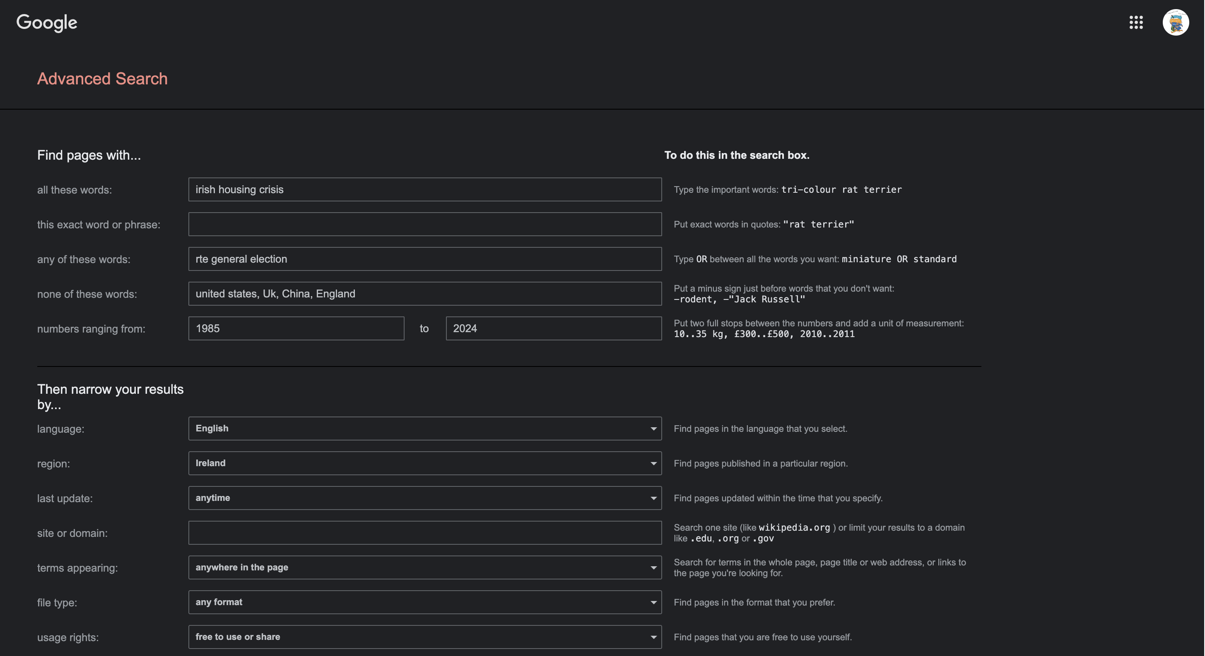

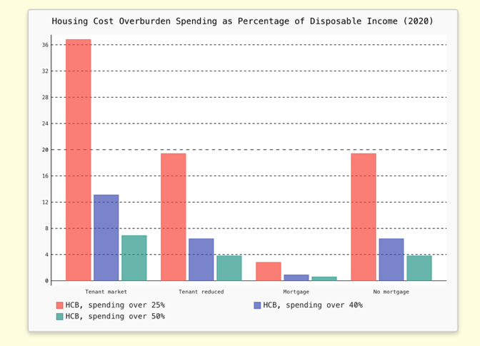
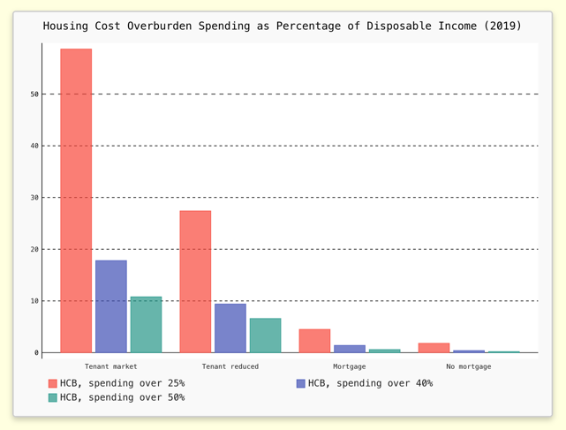

I found many interesting insights during my further research into the topic. I noticed the HCO rate for households without mortgages in the year 2020 is significantly higher than in other years compare to household with mortgages. Logically, households without loans should be spending a smaller percentage of their disposable income on housing compared to those with loan obligations. Upon further research, I found that the COVID-19 pandemic was the key driver behind this phenomenon.

(https://tradingeconomics.com/ireland/housing-cost-overburden-rate-owner-no-outsting-mortgage-or-housing-loan-eurostat-data.html)

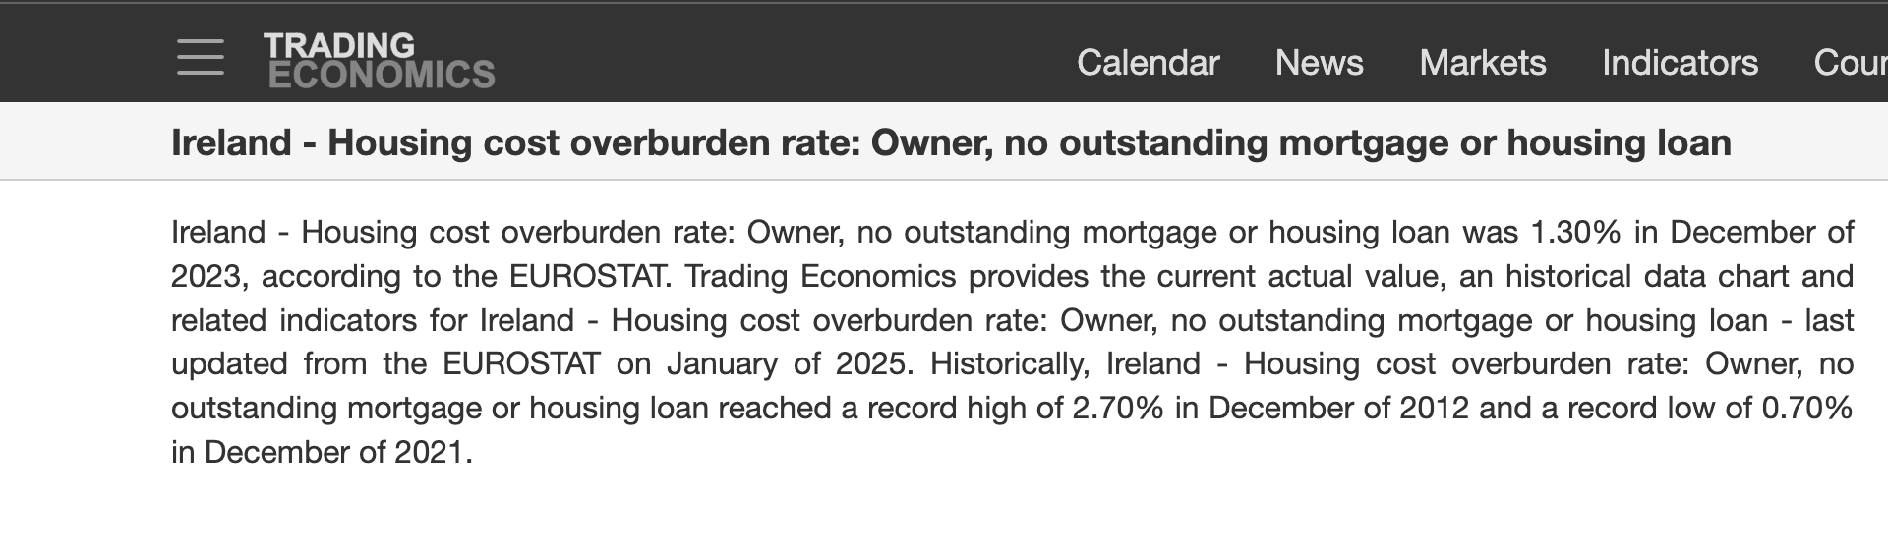



http://files.nesc.ie/nesc_background_papers/c19-housing.pdf\

